The 'comm' command **compares two files or streams**. By default, 'comm' will always display three columns. First column indicates non-matching items of first file, second column indicates non-matching items of second file, and third column indicates matching items of both the files.

The 'comm' command compares two files or streams. By default, 'comm' will always display **three columns**. First column indicates non-matching items of first file, second column indicates non-matching items of second file, and third column indicates matching items of both the files. Both the files has to be in sorted order for 'comm' command to be executed.

**Syntax:**

1. comm <file1> <file2>

**Example:**

1. comm file1.txt file2.txt

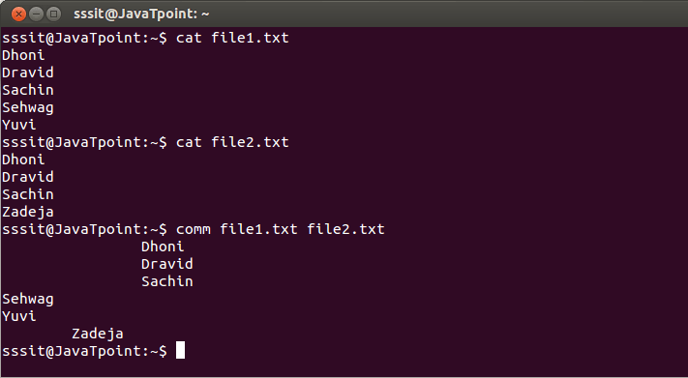

First column displays non-matching items of first file 'file1.txt' (Sehwag, Yuvi)

Second column displays non-matching items of second file 'file2.txt' (Zadeja)

Third column indicates matching items of both the files (Dhoni, Dravid, Sachin)

**To Display Single Column**

If you want to output a single column, you have to specify number of the columns which are not to be displayed.

**Syntax:**

comm -23 (To display first column)

comm -13 (To display second column)

comm -12 (To display third column)

**Example:**

comm -23 file1.txt file2.txt

comm -13 file1.txt file2.txt

comm -12 file1.txt file2.txt

